Name : Kanhaiya Tyagi PRN : 25070521157
3.1.2] Celsius to Fahrenheit
ALGORITHM
Step 1:- Start
Step 2 ;- Read temperature in Celsius as float value Celsius
Step 3:- Calculate Fahrenheit using formula:
$$fahrenheit=(celsius×\frac{9}{5})+32$$
Step 4 :- Print the Fahrenheit value formatted to 2 decimal places
Step5:- Stop
FLOWCHART
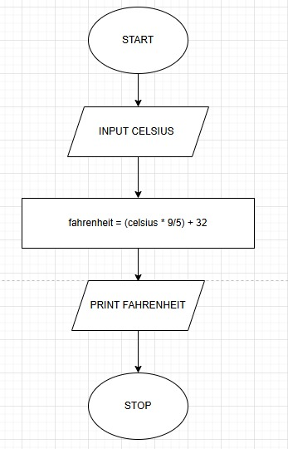
PYTHON CODE
celsius = float(input())

fahrenheit = (celsius * 9/5) + 32
print(f"{fahrenheit:.2f}")

EXCECUTION
